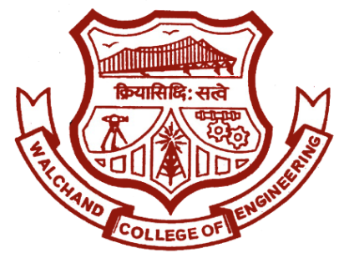

Walchand College of Engineering, Sangli.

(An autonomous institute)

&

Electronics Engineering Students’ Association

(ELESA)

Website: [www.elesa.co.in](http://www.elesa.co.in)

Email: elesa1819@gmail.com

ELECTROVERT 2018

Performers creed

EVENT STRUCTURE

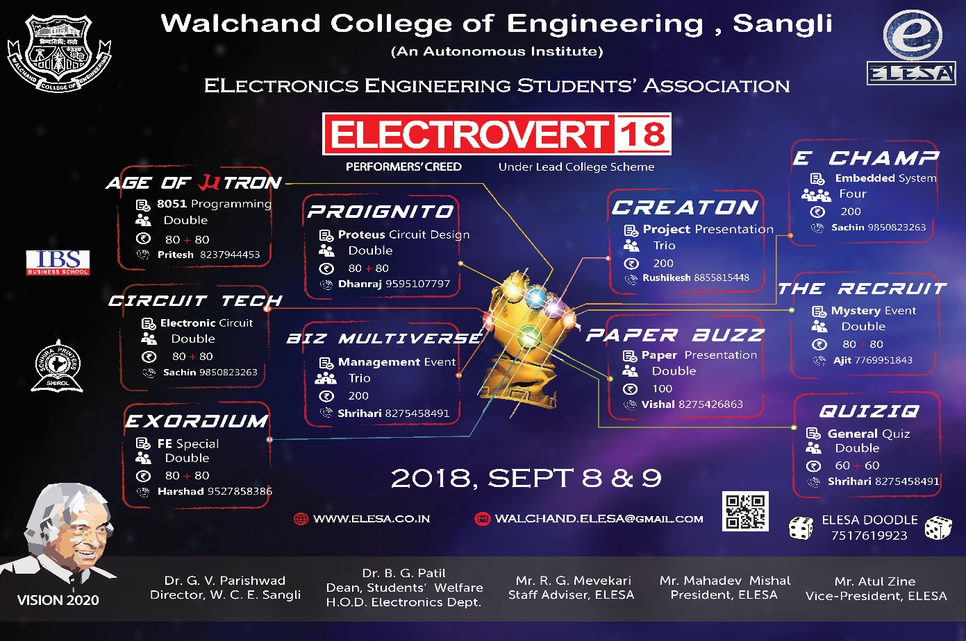

About Electrovert

**ELECTROVERT** is a **State Level Event** organised for engineering and technology students by ELESA, a technical club of dept. of Electronics at Walchand College of Engineering, Sangli. It entails **Technical, Management and soft skills competitions** to provide a better platform to showcase talent for engineering and technology students across the Maharashtra. The students from other universities and colleges participate in the event like Govt. College Of Engg.–karad, Sinhgad College Of Engg.-Pune, RIT-Islampur, Kolhapur Institute of technology, Dr. D Y Patil College of Engg. etc.

Electrovert has a glory of about 12 years and each years the success curve is upgoing with latest record of 600 teams contributing to more than **1200 participants** in Electrovert 2017. Electrovert is a **2 day event** organising minimum 10 major sub-events. The day 1 majorly includes technical and management competitions. The second day comprises of soft skill competitions, technical and non-technical quiz competition.

One of the major attraction of Electrovert is **ELECTROCHAMP**. It is an embedded system designing and building event for solving real life problem set according to the theme of Electrovert.

ELECTROVRT 2018 will consist of following sub events:

|  |  |
| --- | --- |
| **Day 1 (8th Sep)** | **Day 2 (9th Sep)** |
| Age of u-tron | E-Champ |
| Circuit-Tech | QuizIQ |
| Proignito | The Recruit |
| Exordium | Paper Buzz |
| Biz-Multiverse | Creaton |

The **OBJECTIVES** of the ELECTROVERT are

* To Encourage creativity of the students by nurturing their ideas and inducing the feeling of social binding
* To impart industrial knowledge and real life problem solving thinking within the students by arranging different technical competitions, workshops and Guest Lectures to enhance employability of the students to work in core Electronics industries.

**Microcontroller based programming event:**

The event will be a whole day event. It will cover the questions which will test the knowledge of students about embeddded systems and 8051 microcontroller.

* Each team will be consisting of 2 members.
* Entry fee will be 80(1st round) + 80(2nd round)
* Event will be conducted in 3 rounds
* Event Structure:
* **Round 1-Multiple Choice Questions: (10:30am to 11:00am)**

It will be objective test consisting of 40 questions and allocated time will be 30 minutes. 20 questions will be on 8051 microcontroller and its features while remaining 20 will be on Design of Embedded systems.

Topics- Assembly language instructions, Architecture (RISC & CISC), peripherals etc.

* **Round 2-Rapid programming and program debugging: (1:30pm to 2:15pm)**

From those 3 questions 1 must be solved by assembly language programming style and 2 can be solved by C programming style. Results will be observed on KEIL and Proteus softwares. This round will be held in ESM Lab of Electronics Department.

* **Round 3-Hardware implementation of problem: (4:30pm to 5:30pm)**

We will shortlist ‘Top-8’ teams for finale. They will be given only one complex problem statement and allocated time will be 1-hour. This round will be held in ESM Lab of Electronics Department. Respected Professors from WCE will judge this round.